**Requirement Scope Document**

**[RSD – Tour Package-Phase 1]**



|  |  |  |  |
| --- | --- | --- | --- |
| **Project ID & Name** | **OTA- Tour Package** | | |
| **Project Manager** | Mohammad Faruk | | |
| **Customer Request Reference** |  | | |
| **Prepared by** | Farzana Islam | **Date** | 28 August 2023 |
| **Reviewed by** | Mohammad Faruk | **Date** |  |

**Revision History**

|  |  |  |  |  |
| --- | --- | --- | --- | --- |
| **Ver. No** | **Date** | **Prepared By** | **Approved By** | **List of changes from the Previous Version** |
| 0.01 | 28 Aug 2023 | Farzana Islam, Sr. Business Analyst |  | Initiation of the RSD |
| 0.02 | 10 Sept 2023 | Farzana Islam, Sr. Business Analyst |  | Advertisement setup |
| 0.03 | 12 Sept 2023 | Farzana Islam, Sr. Business Analyst |  | Incorporation of the below change   1. Package tag setup 2. Next trip tag setup 3. Mail Responses 4. Lighting details 5. Count down /Availability tracking |
| 0.04 | 13 Sept 2023 | Farzana Islam, Sr. Business Analyst |  | Incorporation of the below change   1. Adding activity log 2. Adding of payment link in the booking process |
| 0.05 | 16 Sept 2023 | Farzana Islam, Sr. Business Analyst |  | Correction of typo mistakes and update of business rules. |
| 0.06 | 17 Sept 2023 | Farzana Islam, Sr. Business Analyst |  | Correction of typo mistakes and update of business rules. |
| 0.07 | 19 Sept 2023 | Farzana Islam, Sr. Business Analyst |  | Incorporation of change in Business Rules and UI based on BD design and process needs. |
| 0.08 | 03 Oct 2023 | Farzana Islam, Sr. Business Analyst |  | Correction of the SRS formate. |
| 0.09 | 16 Oct 2023 | Farzana Islam, Sr. Business Analyst |  | 1. Update of the calculation of the package price 2. Business of adding more buttons of respective UI 3. Business of toggle button |
| 0.10 | 21 Oct 2023 | Farzana Islam, Sr. Business Analyst |  | 1. Addition of the below business rules for every list view marked in yellow color:    1. Addition of edit button business rules for every UI    2. Addition of business rules for delete button from every UI    3. For every list view by default, 10 items will be in the grid. In the short by field show “10” as selected till further change. 2. Update of business rules for location map link marked in yellow color. |

Table of Content

1. Requirement Scope Summary 4

2. Functional Requirements Identification 4

3. Functional Requirement Details 5

3.1 Process Flow – Tour Package 5

3.1.1 User Interface-Location 6

3.1.1.1 RSD – Location 7

3.1.2 User Interface-Package Category 12

3.1.2.1 RSD – Package Category 12

3.1.3 User Interface-Package Tag 15

3.1.3.1 RSD – Package Tag 15

3.1.5 User Interface-Refund Policy 19

3.1.5.1 RSD – Refund Policy 19

3.1.6 User Interface-General Policy 23

3.1.6.1 RSD – General Policy 23

3.1.7 User Interface- Child Policy 25

3.1.7.1 RSD – Child Policy 26

3.1.8 User Interface- Package Creation 29

3.1.8.1 RSD – Package Creation 33

1. Other Components 43

2. Non-functional Requirements 43

3. Approved by (Client): 43

# Requirement Scope Summary

Tour package software is a versatile tool that supports travel agencies, tour operators, and travelers in organizing and managing travel experiences. Its scope includes creating and customizing itineraries, handling bookings, managing customer relationships, overseeing inventory, facilitating online bookings, processing payments, providing insights through reporting, managing suppliers, enabling marketing efforts, and ensuring compliance. This software enhances operational efficiency and customer satisfaction by centralizing tasks and automating various travel-related processes.

# Functional Requirements Identification

|  |  |  |
| --- | --- | --- |
| **Sub Module Name** | **SRS ID** | **UI Name** |
| Tour Policy Configuration | 1.1 | Location Setup |
| 1.2 | Package Category setup |
| 1.3 | Package Tag setup |
| 1.4 | Payment, Cancel & Refund Policy |
| 1.5 | Child and Infant policy |
| 1.6 | General Policy |
| Tour Package | 2.1 | Package Creation |

# 

# Functional Requirement Details

# Process Flow – Tour Package

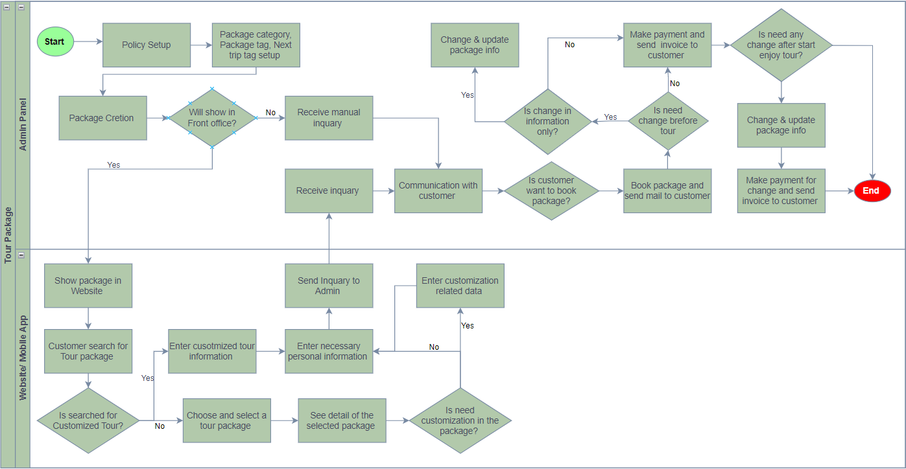

Figure – Tour Package Process Flow

### User Interface-Location

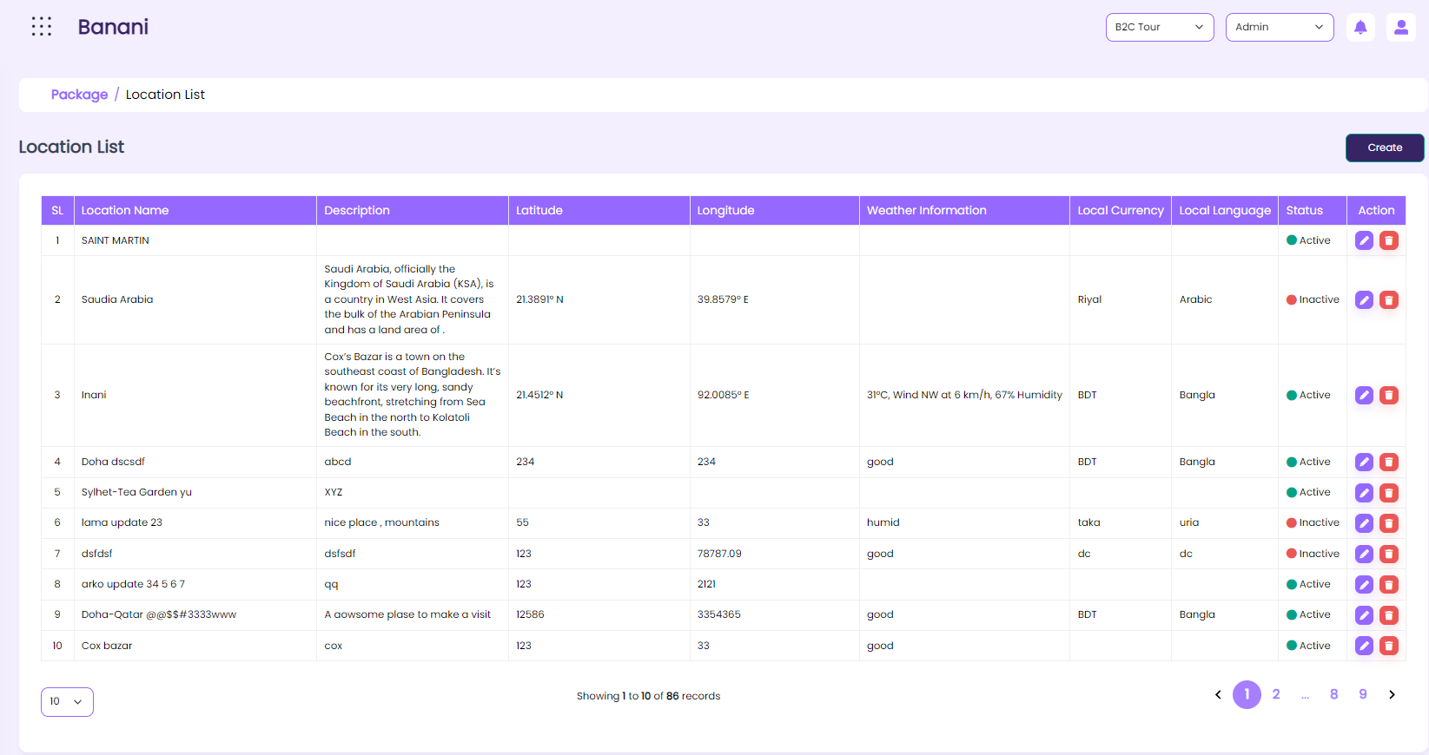

Figure – Location -List view

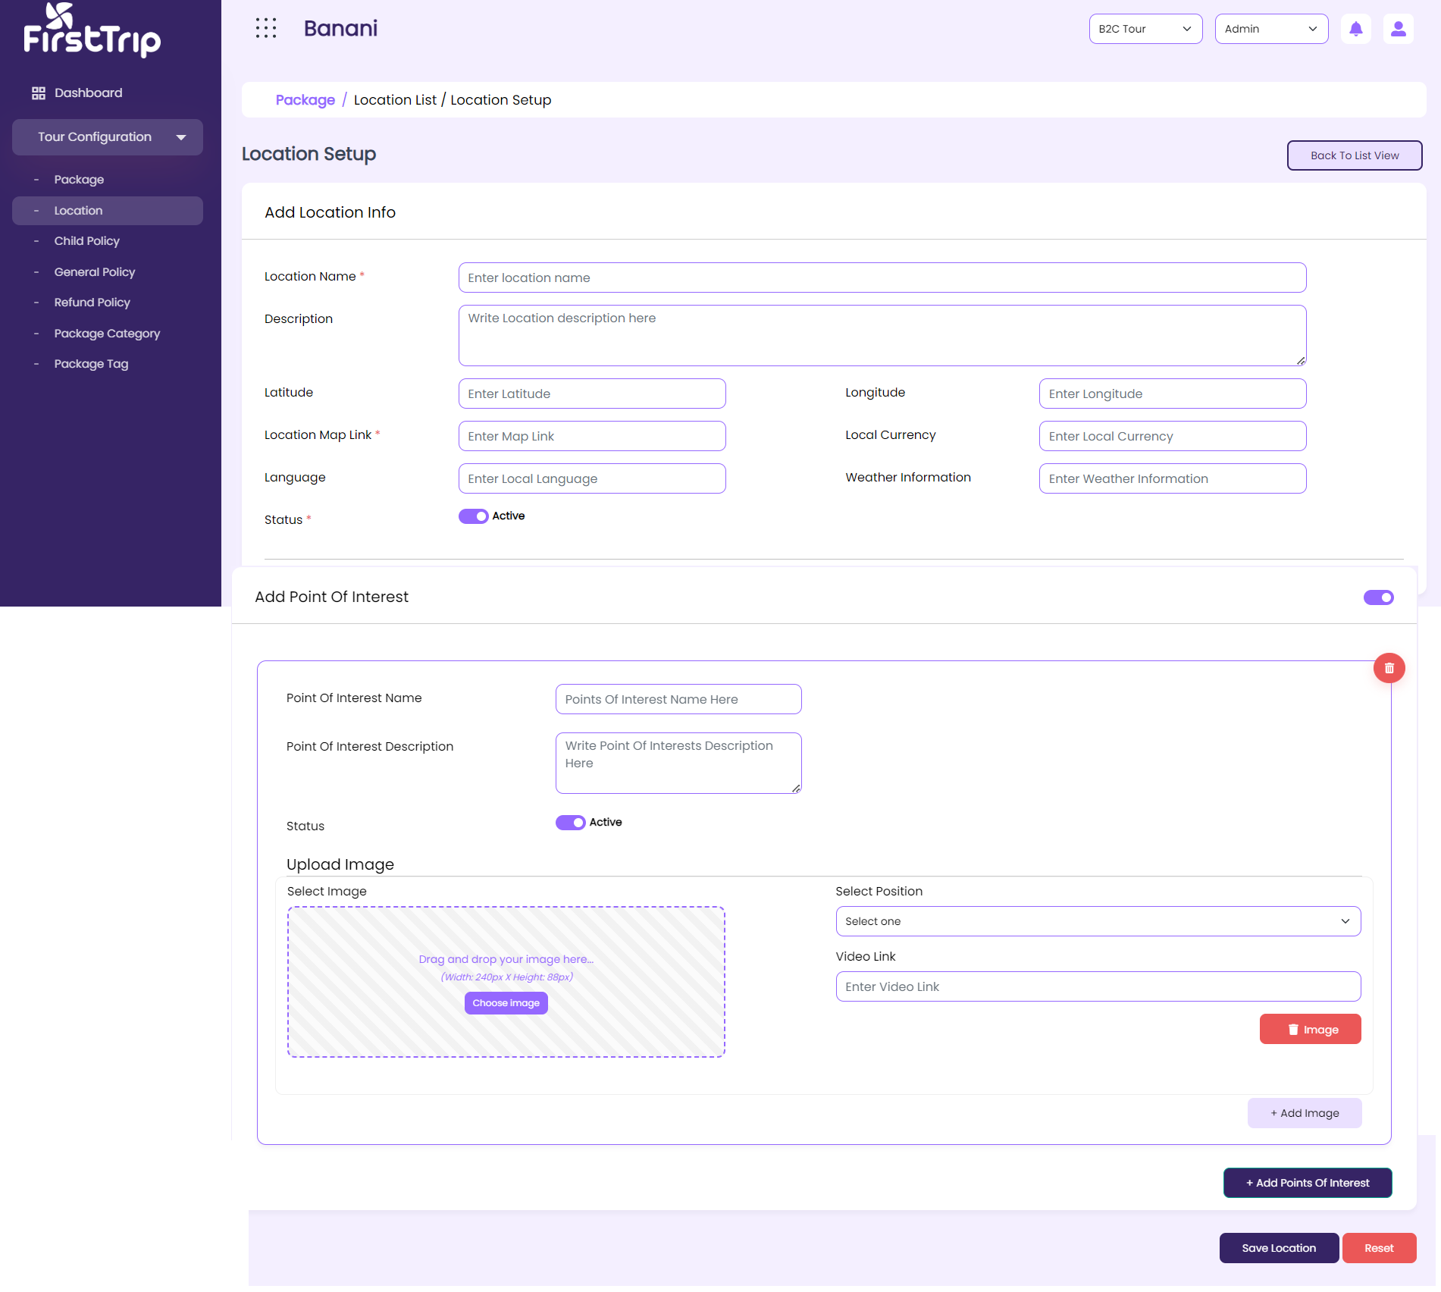

Figure – Location- Create

### RSD – Location

|  |  |
| --- | --- |
| **SRS ID** | SRS1.2 |
| **SRS Title** | Location |
| **Proposed Requirement** | 1. Users will be able to view the list of created Package category in the list view 2. Users will be able to create a location with the required data from the location creation UI 3. Users will be able to update location-related information from the creation UI. |
| **Precondition** | 1. The user must have a valid user ID and Password to log into the system. 2. The user must have permission for this function and access this UI. |
| **Business rules** | 1. On coming to this UI system will show a Grid with the below data :    1. SL No       1. System generated chronological number    2. Location Name    3. Description    4. Latitude    5. Longitude    6. Points of interest       1. The System will show multiple points of interest names in tab read-only views mode.    7. Weather Information    8. Local currency    9. Language    10. Status        1. Active        2. Inactive 2. Location Setup    1. Location name       1. Required       2. Free text field    2. Description       1. Optional       2. Free text field    3. Latitude, longitude       1. Optional       2. Free text field    4. Location map link       1. Required       2. Free text field       3. On uploading an embedded Open map link the system will show the respective map in the web for the respective package for which the location is mapped.    5. Weather information, Local currency, language       1. Optional       2. Free text field    6. Status       1. Required       2. By default, the check box will be checked and the system will show the “Active” level beside the check box.       3. On unchecking system will consider the item as inactive and the “inactive” status will show beside the status field instead of the “active” status.    7. Point of interest       1. On making the toggle button active the system will show the below fields to enter data in the respective fields.       2. On making in active the toggle the system will allow users to save the location information without adding any point of interest-related information       3. Point of interest name   Required  Free text filed   * + 1. Points of interest description   Optional  Free text field   * 1. Vlog link      1. Optional      2. YouTube video link   2. Upload Image      1. Required      2. The User will be able to add single/multiple points of interest names here.      3. The user will be able to add a Package category and multiple images in respect of points of interest.   3. Position      1. Required      2. Dropdown         1. Gallery         2. Cover      3. For every image user has to select the position      4. Based on the selection of the position, the system will show this image in both Web and Mobile apps.   4. Add more      1. Upon clicking the add more button the user will be able to add more images against a point of interest      2. On clicking add more the below field will be loaded again for new information and the described rules for the respective field will be implemented         1. Upload image         2. Vlog link         3. Position   5. Status      1. Required      2. By default, the check box will be checked and the system will show the “Active” level beside the check box.      3. On unchecking, the system will consider the item as inactive and the “inactive” status will show beside the status field instead of the “active” status.   6. The user will be able to set single/multiple points of interest against a location.   7. The user will be able to make active or inactive single/multiple points of interest against a location   8. Add Point of interest      1. Upon clicking the button the user will be able to add more points of interest information      2. On clicking add more the below field will be loaded again for new information and the described rules for the respective field will be implemented         1. Point of interest name         2. Point of interest description         3. Upload image         4. Vlog link         5. Position  1. The user will be able to make a specific location active or inactive and the system will show the status based on this in the list view. 2. Clicking the Create button from the list view, the system will take the user to the Location setup UI. 3. The user will be able to navigate from the location setup to the location list by clicking the “Back to List” button. 4. Clicking the edit icon in the list view, the system will load the respective data in the create UI in edit mode. 5. The system will keep the user on the creation page along with the last saved data in edit mode, till the user makes any interaction. 6. Clicking on the delete button from the list view, the system will delete the item from the list. The system will show a successful message in the toast message “Data deleted successfully”. This data will be kept in the DB. user will not be able to see the deleted data in the list. 7. If the data is used anywhere in the entire operation the system will not allow the user to delete the respective data from the list. The system will show a toast message that “This item is already used with Package creation. 8. By default, 10 items will be in the grid. In the short by field show “10” as selected till further change. |
| **Post-Condition** | 1. The User will be able to use the created location during Tour package creation. 2. The user will be able to use only the active location and respective points of interest during package creation. 3. The inactive location and points of interest will not come in the list of location fields during the creation of the package. |
| **Requirement Collection Method** | Document Analysis, Existing system Analysis, Requirements gathering session. |
| **Priority** | High |

### User Interface-Package Category

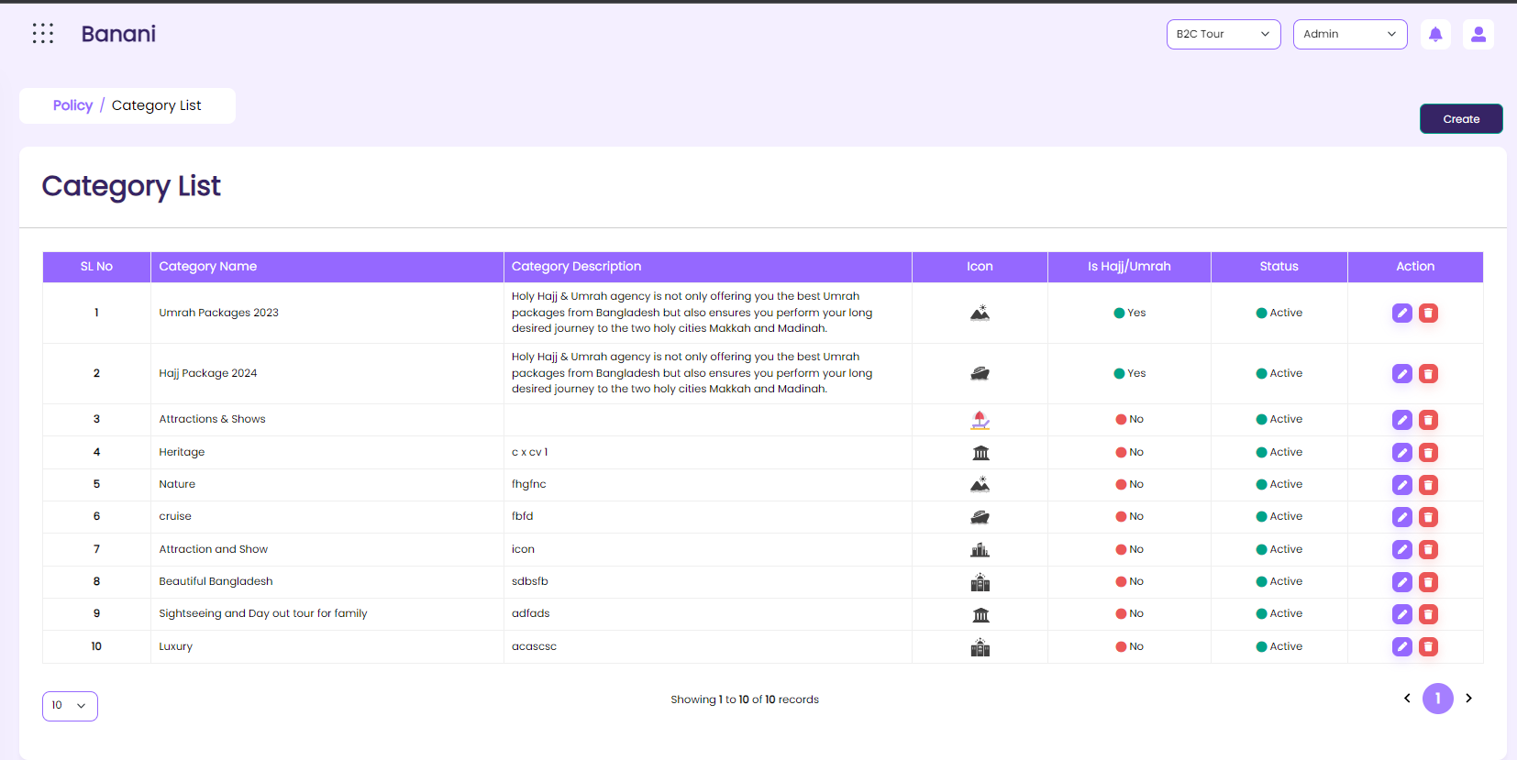

Figure – Package Category -List

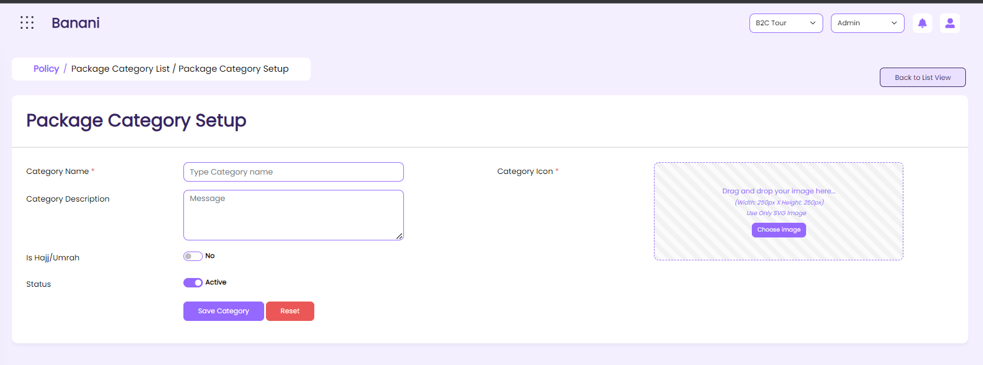

Figure – Package Category -Create

### RSD – Package Category

|  |  |
| --- | --- |
| **SRS ID** | SRS1.3 |
| **SRS Title** | Package Category |
| **Proposed Requirement** | 1. Users will be able to view the list of created Package category in the list view 2. Users will be able to create a Package category with the required data from the package category creation UI 3. Users will be able to update Package category-related information from the creation UI. |
| **Precondition** | 1. The user must have a valid user ID and Password to log into the system. 2. The user must have permission for this function and access this UI. |
| **Business rules** | 1. On coming to this UI system will show the grid with the below data:    1. SL No       1. System generated chronological number    2. Category name    3. Description    4. icon    5. Is Hajj/Umrah    6. Status 2. The user will be able to make a specific package category active or inactive and the system will show the status based on this in the list view. 3. Clicking the Create button from the list view, the system will take the user to the package category setup UI. 4. The user will be able to navigate from the package category setup to the package category list by clicking the “Back to List” button. 5. Clicking the edit icon in the list view, the system will load the respective data in the create UI in edit mode. 6. The system will keep the user on the creation page along with the last saved data in edit mode, till the user makes any interaction. 7. Clicking on the delete button from the list view, the system will delete the item from the list. The system will show a successful message in the toast message “Data deleted successfully”. This data will be kept in the DB. user will not be able to see the deleted data in the list. 8. If the data is used anywhere in the entire operation the system will not allow the user to delete the respective data from the list. The system will show a toast message that “This item is already used with Package creation. 9. By default, 10 items will be in the grid. In the short by field show “10” as selected till further change. 10. Package category setup     1. Category Name        1. Required        2. Free text field     2. Description        1. Optional        2. Free text field     3. Icon        1. Required        2. Upload of image        3. The image size is 250x250px maximum and the max limit will be 6 MB.     4. Is Hajj/Umrah        1. Selection of checkbox        2. By default, the check box will be unchecked.     5. Status        1. Required        2. By default, the check box will be checked and the system will show the “Active” level beside the check box.        3. On unchecking, the system will consider the item inactive, and the “inactive” status will show beside the status field instead of the “active” status. |
| **Post-Condition** | 1. The User will be able to use the created category during Tour package creation. 2. The user will be able to use only the active package category and respective points of interest during package creation. 3. The in-active package category will not come in the package category field during the creation of the package. |
| **Requirement Collection Method** | Document Analysis, Existing system Analysis, Requirements gathering session. |
| **Priority** | High |

### User Interface-Package Tag

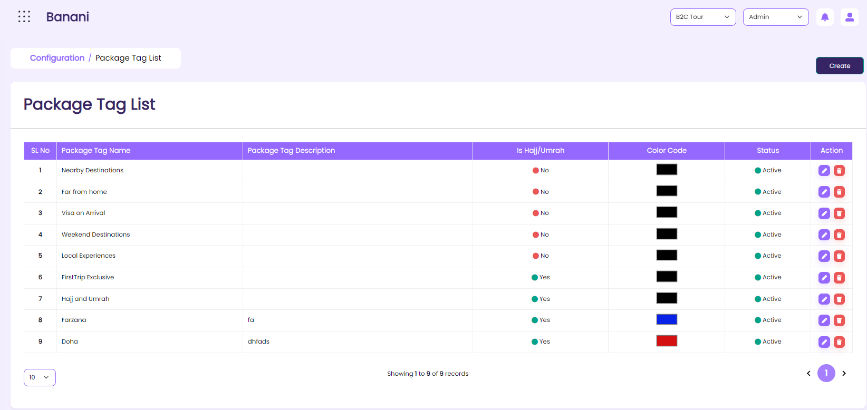

Figure – Package Tag-List

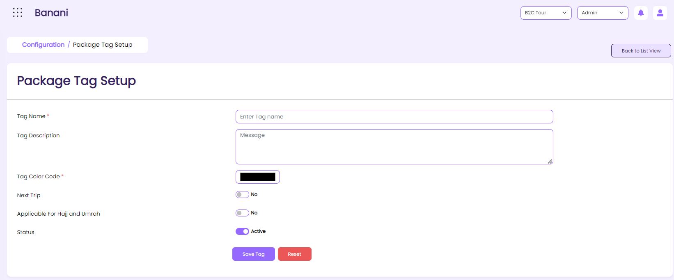

Figure – Package Tag-Create

### RSD – Package Tag

|  |  |
| --- | --- |
| **SRS ID** | SRS1.5 |
| **SRS Title** | Package Tag |
| **Proposed Requirement** | 1. Users will be able to view and update Package tag-related information from this UI. 2. Users will be able to create a Package tag with the required data from the Package tag creation UI 3. Users will be able to update Package tag-related information from the creation UI. |
| **Precondition** | 1. The user must have a valid user ID and Password to log into the system. 2. The user must have permission for this function and access this UI. |
| **Business rules** | 1. On coming to this UI system will show the grid with the below data:    1. SL No       1. System generated chronological number    2. Package tag name    3. Description    4. Is Hajj/Umrah    5. Color code    6. Status 2. The user will be able to make a specific package tag active or inactive and the system will show the status based on this in the list view. 3. Clicking the Create button from the list view, the system will take the user to the package tag setup UI. 4. The user will be able to navigate from the package tag to the package tag list by clicking the “Back to List” button. 5. Clicking the edit icon in the list view, the system will load the respective data in the create UI in edit mode. 6. The system will keep the user on the creation page along with the last saved data in edit mode, till the user makes any interaction. 7. Clicking on the delete button from the list view, the system will delete the item from the list. The system will show a successful message in the toast message “Data deleted successfully”. This data will be kept in the DB. user will not be able to see the deleted data in the list. 8. If the data is used anywhere in the entire operation the system will not allow the user to delete the respective data from the list. The system will show a toast message that “This item is already used with Package creation. 9. By default, 10 items will be in the grid. In the short by field show “10” as selected till further change. 10. Package tag setup     1. Tag Name        1. Required        2. Free text field     2. Description        1. Optional        2. Free text field     3. Color Code        1. Required        2. Selection of color from the color palate        3. Based on the selection of the color, the system will show the selected color with the tag name on the website upon filtering a package based on the respective tag.     4. Is Hajj/Umrah        1. Selection of checkbox        2. By default, the check box will be unchecked.     5. Next trip tag        1. Selection of checkbox        2. By default, the check box will be unchecked.     6. Status        1. Required        2. By default, the check box will be checked and the system will show the “Active” level beside the check box.        3. On unchecking, the system will consider the item as inactive and the “inactive” status will show beside the status field instead of the “active” status. |
| **Post-Condition** | 1. The User will be able to use the created tag during Tour package creation. 2. The user will be able to use only the active package tag and respective points of interest during package creation. 3. The in-active package tag will not come in the package category field during the creation of the package. |
| **Requirement Collection Method** | Document Analysis, Existing system Analysis, Requirements gathering session. |
| **Priority** | High |

### User Interface-Refund Policy

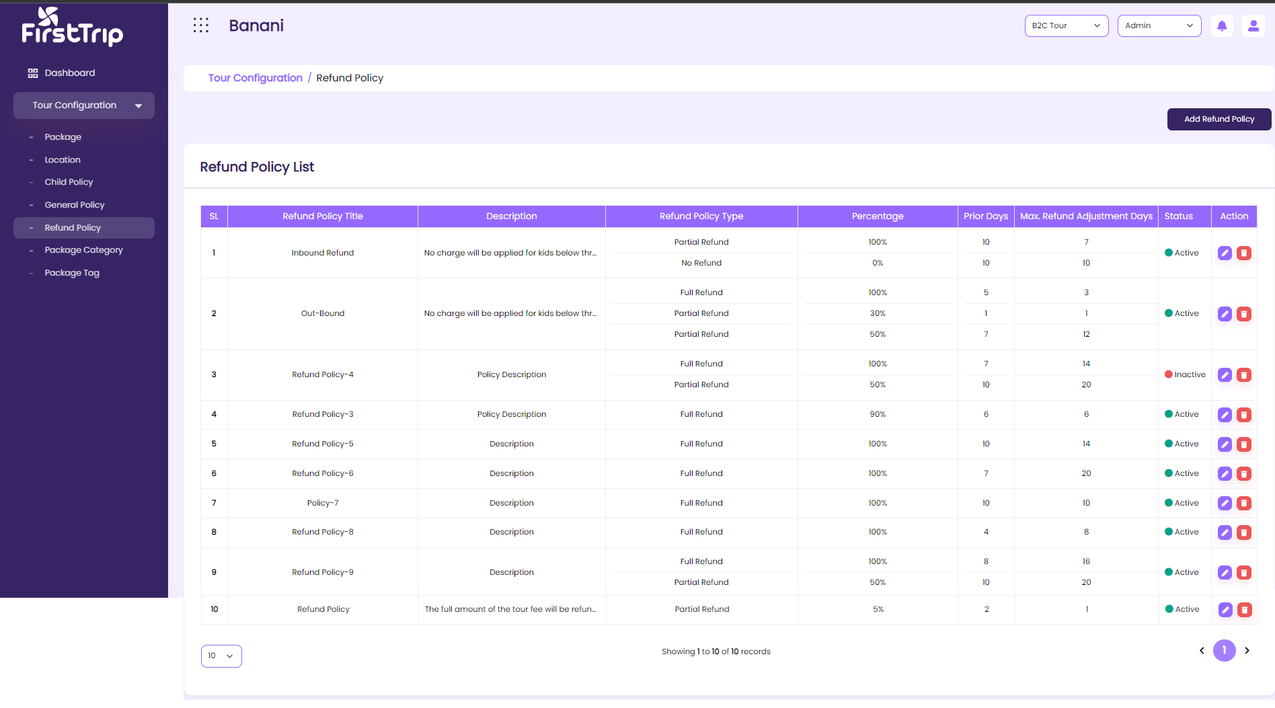

*Figure – Refund Policy -List*

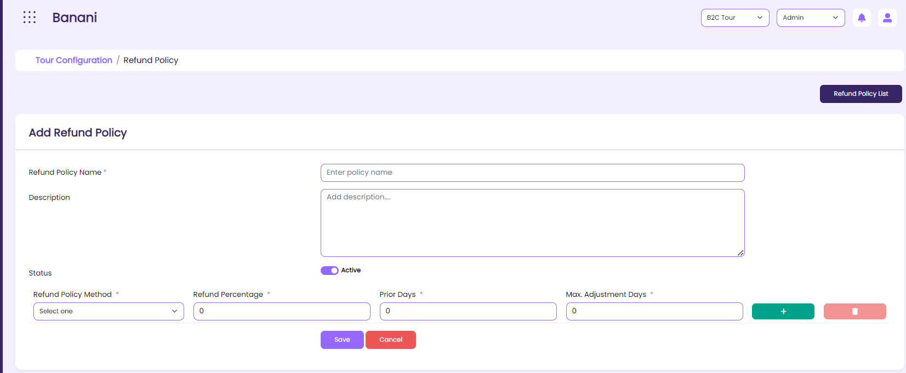

*Figure – Refund Policy -Create*

### RSD – Refund Policy

|  |  |
| --- | --- |
| **SRS ID** | SRS1.7 |
| **SRS Title** | Refund Policy |
| **Proposed Requirement** | 1. Users will be able to view and update refund policy-related information from this UI. 2. Users will be able to create a re with the required data from the refund policy creation UI 3. Users will be able to update refund policy-related information from the creation UI. |
| **Precondition** | 1. The user must have a valid user ID and Password to log into the system. 2. The user must have permission for this function and access this UI. |
| **Business rules** | 1. The system will show the below grid here    1. Sl No       1. System generated chronological number    2. Refund Policy Title    3. Refund Policy Description    4. Refund Policy Type    5. Refund Percentage    6. Prior payment    7. Max. Refund Adjustment days 2. The user will be able to make a specific Refund policy active or inactive and the system will show the status based on this in the list view. 3. Clicking the Create button from the list view, the system will take the user to the refund policy setup UI. 4. The user will be able to navigate from the refund policy creation UI to the refund policy list by clicking the “Back to List” button. 5. Clicking the edit icon in the list view, the system will load the respective data in the create UI in edit mode. 6. The system will keep the user on the creation page along with the last saved data in edit mode, till the user makes any interaction. 7. Clicking on the delete button from the list view, the system will delete the item from the list. The system will show a successful message in the toast message “Data deleted successfully”. This data will be kept in the DB. user will not be able to see the deleted data in the list. 8. If the data is used anywhere in the entire operation the system will not allow the user to delete the respective data from the list. The system will show a toast message that “This item is already used with Package creation. 9. By default, 10 items will be in the grid. In the short by field show “10” as selected till further change. 10. Refund Policy Setup     1. Refund Policy title        1. Required        2. Free text field     2. Refund Policy Description        1. Optional        2. Free text field     3. Refund Policy Type        1. Required        2. Dropdown           1. Full Refund           2. Partial Refund           3. No Refund     4. Refund percentage        1. Required        2. Numeric        3. The system will allow users to enter decimal after digit     5. Prior, Max. Refund adjustment Days        1. Required        2. Numeric     6. Status        1. Required        2. By default, the check box will be checked and the system will show the “Active” level beside the check box.        3. On unchecking, the system will consider the item as inactive and the “inactive” status will show beside the status field instead of the “active” status.     7. Add more        1. Upon clicking the button the user will be able to add more policies under one refund policy        2. On clicking add more the below field will be loaded again for new information and the described rules for the respective field will be implemented           1. Refund percentage           2. Prior date           3. Maximum refund adjustment days |
| **Post-Condition** | 1. The user will be able to use this refund policy during package creation, customize package creation, package change, and update. |
| **Requirement Collection Method** | Document Analysis, Existing system Analysis, Requirements gathering session. |
| **Priority** | High |

### User Interface-General Policy

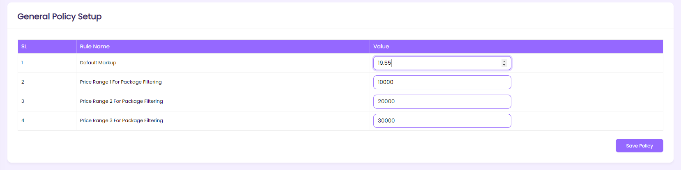

*Figure –General Policy*

### RSD – General Policy

|  |  |
| --- | --- |
| **SRS ID** | SRS1.9 |
| **SRS Title** | General Policy |
| **Proposed Requirement** | 1. Users will be able to view, create, and update general policy-related information from this UI. |
| **Precondition** | 1. The user must have a valid user ID and Password to log into the system. 2. The user must have permission for this function and access this UI. |
| **Business rules** | 1. The System will show the below grid here    1. Field name       1. Readony    2. Details       1. Readonly    3. Status       1. By default will be checked and active.       2. Users will be able to change the status by unchecking the check box       3. The system will not imply the policy anymore if the status is inactive |
| **Post-Condition** | 1. The User will be able to use the created general policy during Tour package creation. |
| **Requirement Collection Method** | Document Analysis, Existing system Analysis, Requirements gathering session. |
| **Priority** | High |

### User Interface- Child Policy

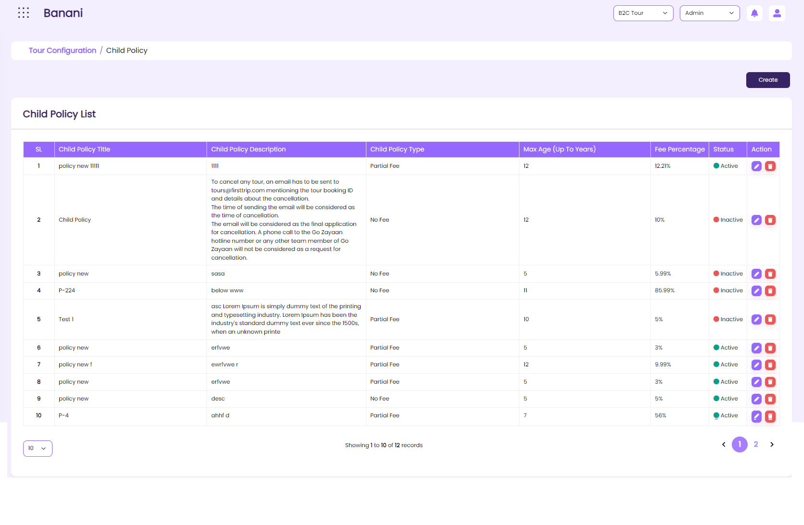

*Figure – Child Policy -List*

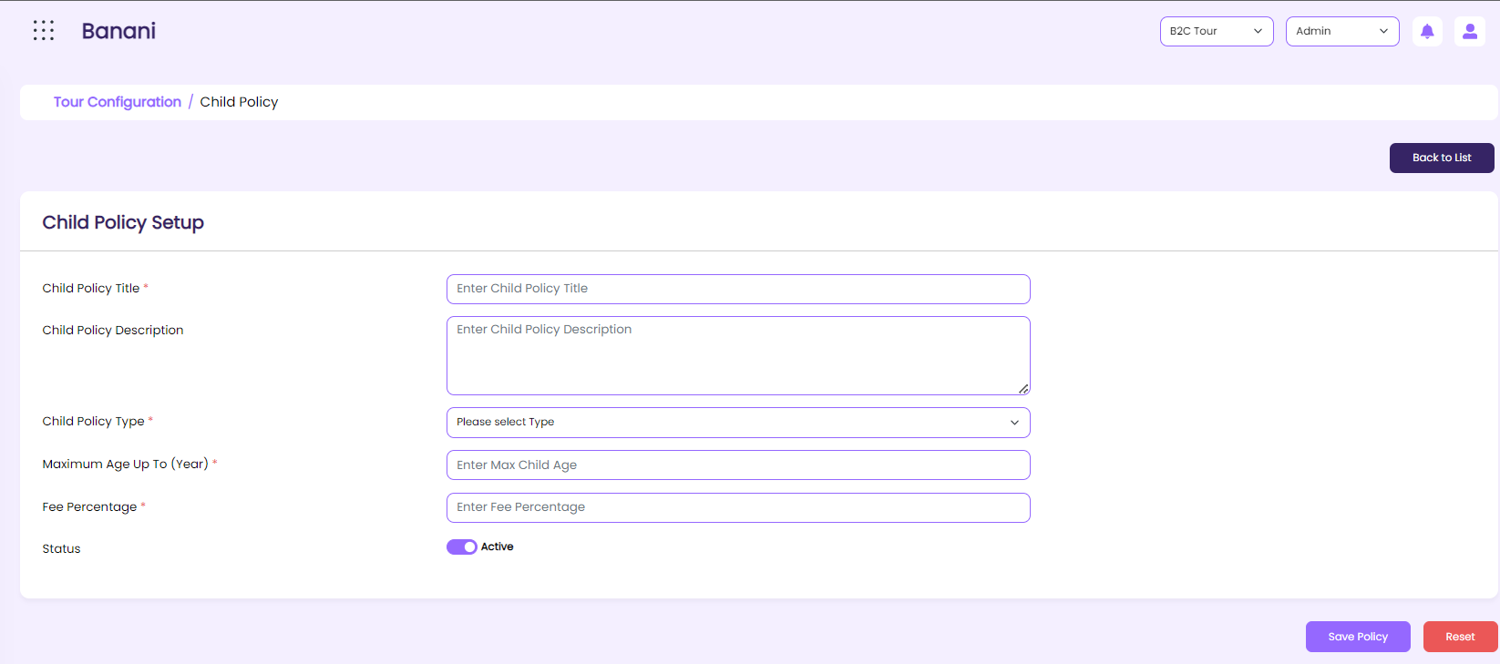

*Figure – Child Policy -Create*

### RSD – Child Policy

|  |  |
| --- | --- |
| **SRS ID** | SRS1.10 |
| **SRS Title** | Child Policy |
| **Proposed Requirement** | 1. Users will be able to view and update refund policy-related information from this UI. 2. Users will be able to create a child policy with the required data from the child policy creation UI 3. Users will be able to update child policy-related information from the creation UI. |
| **Precondition** | 1. The user must have a valid user ID and Password to log into the system. 2. The user must have permission for this function and access this UI. |
| **Business rules** | 1. The System will show the below grid here    1. Sl No    2. Child Policy title    3. Child policy description    4. Child policy type    5. Max Age (Up to years)    6. Fee Percentage 2. The user will be able to make a specific child policy active or inactive and the system will show the status based on this in the list view. 3. Clicking the Create button from the list view, the system will take the user to the child policy setup UI. 4. The user will be able to navigate from the child policy creation UI to the child policy list by clicking the “Back to List” button. 5. Clicking the edit icon in the list view, the system will load the respective data in the create UI in edit mode. 6. The system will keep the user on the creation page along with the last saved data in edit mode, till the user makes any interaction. 7. Clicking on the delete button from the list view, the system will delete the item from the list. The system will show a successful message in the toast message “Data deleted successfully”. This data will be kept in the DB. user will not be able to see the deleted data in the list. 8. If the data is used anywhere in the entire operation the system will not allow the user to delete the respective data from the list. The system will show a toast message that “This item is already used with Package creation. 9. By default, 10 items will be in the grid. In the short by field show “10” as selected till further change. 10. Child policy creation     1. Child policy title        1. Required        2. Free text field     2. Child policy description        1. Optional        2. Free text field     3. Child policy type        1. Required        2. Dropdown           1. No-Fee           2. Partial Fees     4. Max Age (Up to years)        1. Required        2. Numeric           1. Value: 1-12     5. Fee Percentage        1. Required        2. Numeric        3. Allow decimal after digit 11. The users will be able to create or add multiple child policies in the system. |
| **Post-Condition** | 1. The user will be able to use this refund policy during package creation, customize package creation, package change, and update. |
| **Requirement Collection Method** | Document Analysis, Existing system Analysis, Requirements gathering session. |
| **Priority** | High |

### User Interface- Package Creation

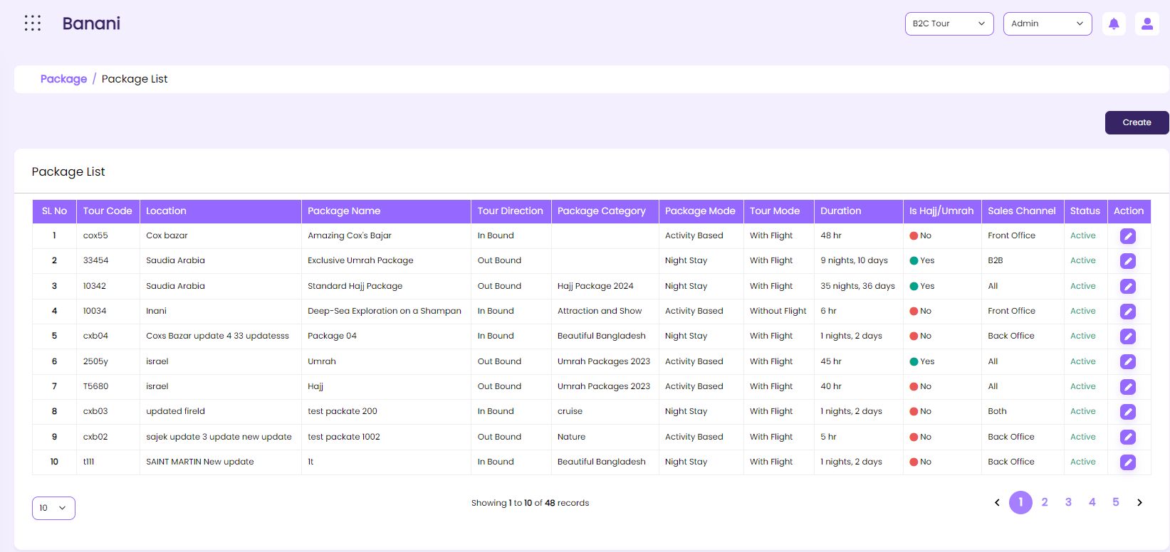

*Figure – Package Creation -List*

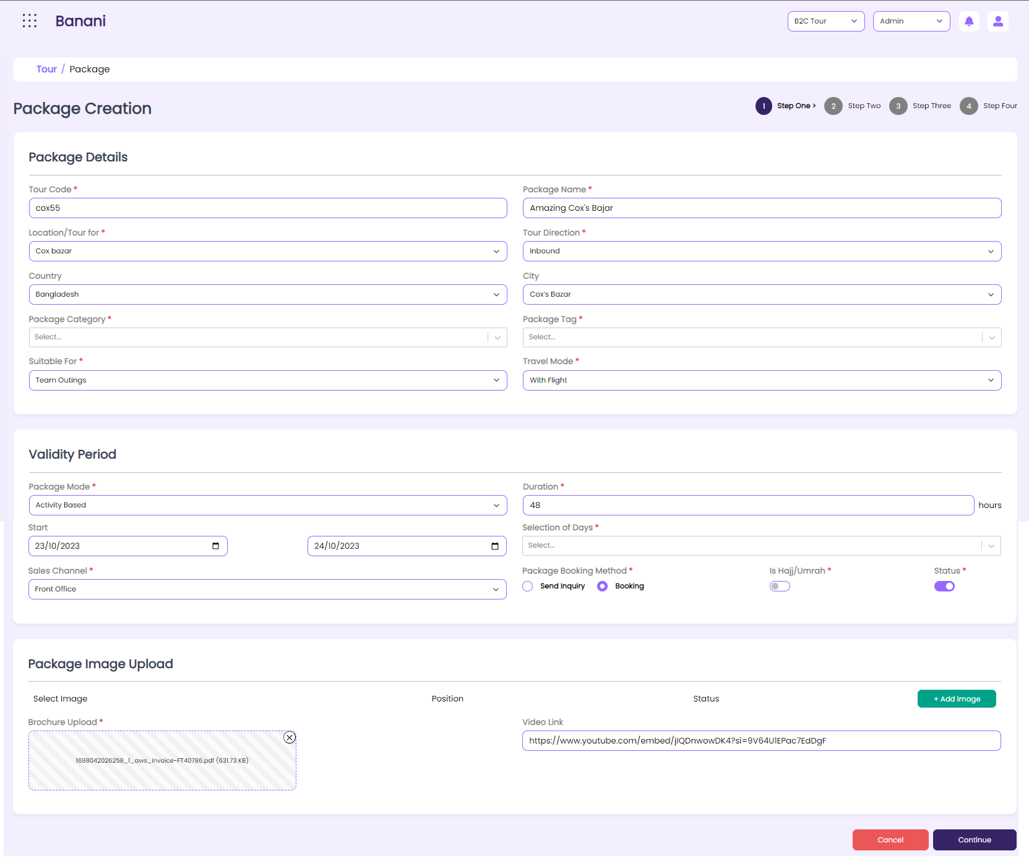

*Figure – Package Creation - Creation -Step-01*

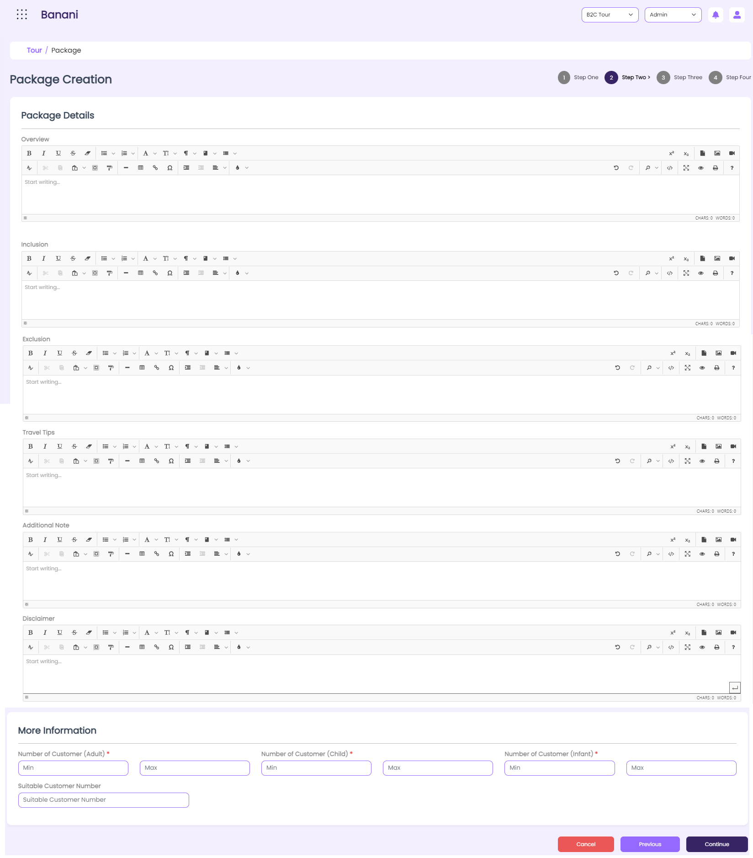

*Figure – Package Creation - Creation -Step-02*

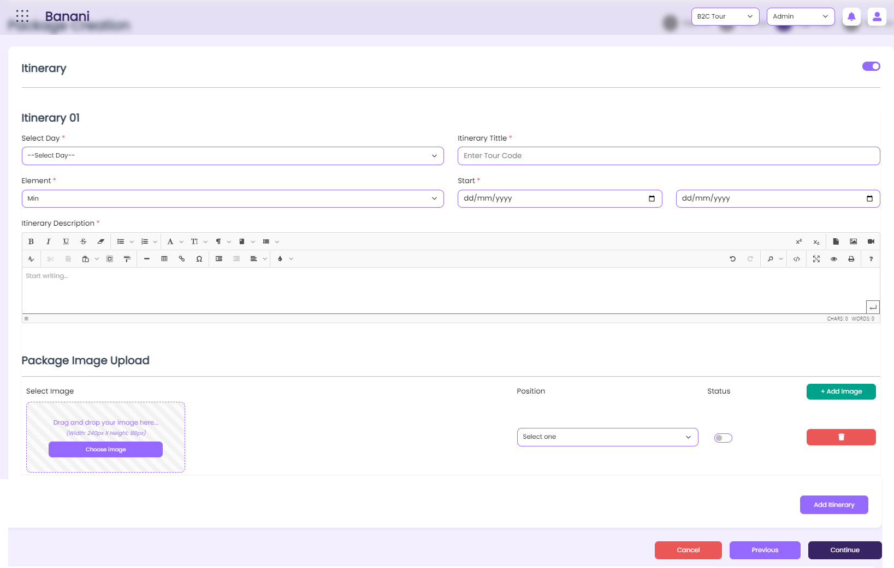

*Figure – Package Creation - Creation -Step-03*

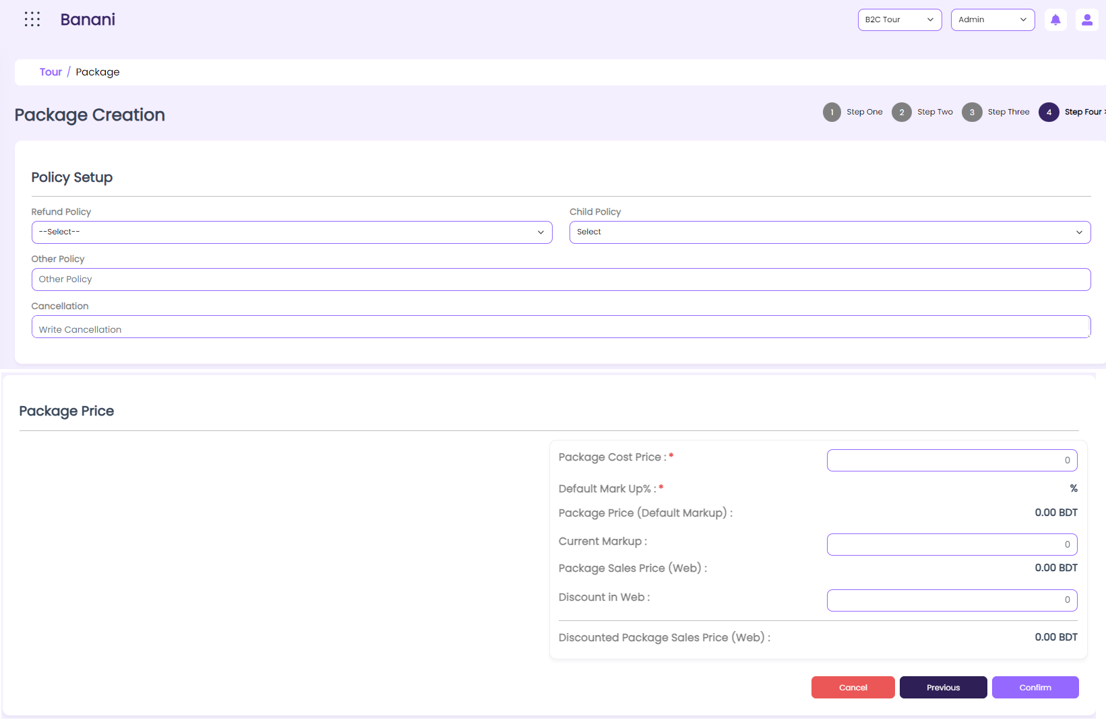

*Figure – Package Creation - Creation -Step-04*

### RSD – Package Creation

|  |  |
| --- | --- |
| **SRS ID** | SRS1.10 |
| **SRS Title** | Package Creation |
| **Proposed Requirement** | 1. Users will be able to view and update package-related information from this UI. 2. Users will be able to create a Tour package with the required data from the refund policy creation UI 3. Users will be able to update refund policy-related information from the creation UI. |
| **Precondition** | 1. The user must have a valid user ID and Password to log into the system. 2. The user must have permission for this function and access this UI. |
| **Business rules** | 1. The System will show the below grid here    1. Sl No       1. System generated chronological number    2. Package Code    3. Location    4. Package Name    5. Tour Direction    6. Package Tag    7. Package Mode    8. Is Hajj /Umrah    9. Duration    10. Package Itinerary        1. Link or icon to redirect to the respective package itinerary page.    11. Sales channel    12. Status 2. The user will be able to make a specific one active or inactive and the system will show the status based on this in the list view. 3. Clicking the Create button from the list view, the system will take the user to the refund policy setup UI. 4. The user will be able to navigate from the creation UI to the package list by clicking the “Back to List” button. 5. Clicking the edit icon in the list view, the system will load the respective data in the create UI in edit mode. 6. The system will keep the user on the creation page along with the last saved data in edit mode, till the user makes any interaction. 7. Clicking on the delete button from the list view, the system will delete the item from the list. The system will show a successful message in the toast message “Data deleted successfully”. This data will be kept in the DB. user will not be able to see the deleted data in the list. 8. If the data is used anywhere in the entire operation the system will not allow the user to delete the respective data from the list. The system will show a toast message that “This item is already used with Package creation. 9. By default, 10 items will be in the grid. In the short by field show “10” as selected till further change. 10. The System will allow users to create a package with the below information     1. Package Code        1. Required        2. Free text filed        3. Not more than 5 digit        4. The System will not allow to give any duplicate code.     2. Location        1. Required        2. Dropdown        3. The system will show only the active location here.     3. Tour Direction        1. Required        2. Dropdown           1. Inbound           2. Outbound     4. Package Name        1. Required        2. Free text field        3. Allow Bangla and English both languages here.     5. Country, city        1. Required        2. Dropdown     6. Package category, package tag        1. Required        2. Dropdown        3. Allow users to select single/multiple values.     7. Suitable for        1. Required        2. Dropdown           1. Friends           2. Family           3. Friends & Family     8. Travel Mode        1. Required        2. Dropdown           1. With Flight           2. Without Flight     9. Package Mode        1. Required        2. Dropdown        3. Based on the selection of the mode system will allow users to set the date and time           1. Night stay           2. Activity-based        4. If the option is a night stay then the system will show a numeric field to enter a numeric value. The System will count the number of days based on that. The number of days = number of nights +1        5. Selecting the “activity-based” mode system will allow the user to select time “from” and “To”           1. The System will allow the user to add multiple time range           2. For example: 10 am -12.13 pm. 3 pm -4.45 pm     10. Start from, to         1. Optional         2. Selection of date         3. If the user doesn’t select any date system will show the selected days in the calendar from the current date of creation of the package till the next 10 years.         4. If the date range is selected system will show the selected days till the selected date range         5. The system will not allow the user to set any backdate here         6. The to-date must be greater than the from-date     11. Selection of days         1. Required         2. Dropdown         3. Allow to select single /multiple values.            1. Sun, Mon, Tue, Wed, Thu, Fri, Sat         4. selection of days from the week         5. Based on the selection of these days system will show the selected days as active on the website. The rest days will be shown as inactive days and the customer will be able to select only days from active days.     12. Sales channel         1. Required         2. Dropdown         3. The System will allow the user to select multiple /single options here.     13. Package Booking method         1. Required         2. Selection of radio button            1. Send Inquiry            2. Booking         3. By default sending inquiries will be selected         4. Based on the selection of the radio button system will show the inquiry or booking option on the website for the respective Package.     14. Overview, Inclusion, Exclusion, additional Notes, travel tips, Disclaimer, cancellation         1. Optional         2. Free text field         3. Add text editor here. So that the user will be able to edit the text as needed.     15. Upload Image         1. Required         2. The User will be able to add single/multiple points of interest names here.         3. The user will be able to add a Package category and multiple images in respect of points of interest.     16. Position         1. Required         2. Dropdown            1. Gallery            2. Cover         3. For every image user has to select the position         4. Based on the selection of the position, the system will show this image in both Web and Mobile apps.     17. Add more         1. Upon clicking the button the user will be able to add more images         2. On clicking add more the below field will be loaded again for new information and the described rules for the respective field will be implemented            1. Upload image            2. Position     18. Attach Brochure         1. Optional         2. Attachment of PDF file from the device location You might like a package list         3. Required         4. Dropdown     19. Suitable customer Number         1. Optional         2. Free text field     20. Refund Policy         * 1. Dropdown           2. Optional           3. There will be an “ Other” option in the dropdown           4. Based on the selection of the other option system will allow the user to enter text data here.     21. Child Policy         * 1. Dropdown           2. Optional           3. The users will be able to select single /multiple policy           4. There will be an “ Other” option in the dropdown           5. Based on the selection of the other option system will allow the user to enter text data here.     22. Is Hajj/Urah         1. Selection of check box         2. By default, the box will be unchecked     23. Customer limit ( grid view)         1. Adult         2. Child         3. Infant            1. Min, Max            2. Numeric value     24. Itinerary setup         1. On making the toggle button active the system will show the below fields to enter data in the respective fields.         2. On making in active the toggle the system will allow users to save the location information without adding any itinerary         3. Grid view         4. Users will be able to add multiple days         5. Element            1. Dropdown            2. Required         6. Time            1. Required            2. From, to            3. Selection of time         7. Description            1. Optional            2. Free text field            3. Allow text editor here     25. Upload Image         1. Required         2. The User will be able to add multiple images here.     26. Position         1. Required         2. Dropdown            1. Gallery            2. Cover         3. For every image user has to select the position         4. Based on the selection of the position, the system will show this image in both Web and Mobile apps.     27. Add Itinerary         1. Upon clicking the button the user will be able to add more points of interest information         2. On clicking add more the below field will be loaded again for new information and the described rules for the respective field will be implemented related to itinerary setup information.     28. Status         1. Required         2. By default, the check box will be checked and the system will show the “Active” level beside the check box.         3. On unchecking, the system will consider the item as inactive and the “inactive” status will show beside the status field instead of the “active” status.     29. Package price         1. Package cost price            1. Required            2. Numeric            3. Allow decimal after digit         2. Default markup            1. Readonly            2. The system will show this from the general policy         3. Package price (Default markup)            1. Readonly            2. Calculated value            3. package cost price + package cost price *default markup         4. Current markup            1. Optional            2. Numeric            3. The entered value will be considered in percentage         5. Package sales price (Web)            1. Readonly            2. Calculated value            3. package cost price + package cost price *default markup /current mark up            4. If there is a percentage value in both default markup and current markup the system will always consider the current markup to calculate the package sales price. if there is no current markup then the system will consider the default markup percentage for the calculation         6. discount in web            1. Optional            2. Numeric            3. The entered value will be considered in percentage            4. This value will show in the web and mobile apps         7. Discounted package sales price (Web)            1. Readonly            2. Calculated value            3. Package sales price (Web)- sales price (Web)*Discount in Web            4. This value will show on the web and apps as well. |
| **Post-Condition** | 1. The User will be able to use the created package during the Tour package booking, package cancellation, making of payments, and package change as well. |
| **Requirement Collection Method** | Document Analysis, Existing system Analysis, Requirements gathering session. |
| **Priority** | High |

|  |  |
| --- | --- |
| **Post-Condition** | 1. The system will allow users to use the created package during package booking for existing packages and customization of any existing package. |
| **Requirement Collection Method** | Document Analysis, Existing system Analysis, Requirements gathering session. |
| **Priority** | High |

# Other Components

|  |  |
| --- | --- |
| **Assumption** | Not applicable |
| **Constraints** | Not applicable |
| **Requirements Collected By** | 1. Farzana Islam, Sr. Business Analyst |

# 

# Non-functional Requirements

|  |  |
| --- | --- |
| **Title** | **Details** |
| **Authorization** | The system will use the existing authorization and authentication process of the Flight part. |
| **Daily backup** | The daily backup will be taken and will be kept in a separate place. |
| **Portability and compatibility** | This is not an app-based solution so users will not be able to get access from a mobile. Users with valid IDs and passwords will be able to access the system. |
| **Test Environments** |  |
| **Client Environment** |  |
| **Security Requirement** | User group-wise access permission will ensure the security of the system so the user will be able to access & see data for which the user is permitted. |
| **Performance Requirement** | Emails should be sent with a latency of no greater than 6 hours. Each request should be processed within 10 seconds. The UI’s should load in 3 seconds when the number of simultaneous users is > 100 |
| **Others** |  |

# Approved by (Client):

|  |  |  |
| --- | --- | --- |
| **Name** |  |  |
| **Designation** |  |  |
| **Organization** |  |  |
| **Signature & Date** |  |  |